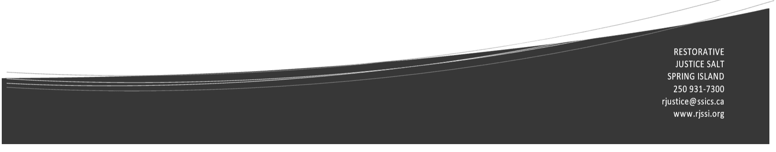

**RESTORATIVE JUSTICE**

Salt Spring Island

**Conflict Resolution**

Restorative practices like Peace Making Circles are ones that we can use to assist people to work through conflicts in a respectful way. We can help individuals, neighbours and communities to resolve conflicts, build relationships and create more trust.

**History**

The RJ Salt Spring Island program began in 1998 and now operates under the Salt Spring Island Community Services Society. There are about 92 RJ and 32 Indigenous Justice Programs in B.C. RJ is part of the B.C. Ministry of Public Safety and Solicitor General.

Volunteers run the Salt Spring Island program with no paid staff. All volunteers go through training to learn how to facilitate both criminal cases referred by the RCMP and conflict cases using a process called Peace Making Circles. Volunteers often have a background in conflict resolution or social service support.

There is an application and selection process in place for those wishing to explore the possibility of volunteering including a criminal record check, references, and interview process.

.

**How can you support the RESTORATIVE JUCTICE program on Salt Spring?**

Now that you are more aware of the program, you can help to identify situations where the RJ program could offer useful services. Assist us to encourage those involved in crime or conflicts to contact us.

We can help people determine if RJ might be a good road for them to take (or not). We can also refer people to other options if RJ is not appropriate.

Perhaps you know of someone who's interested in conflict resolution or peace-building - maybe yourself! We’d be happy to discuss ways to get involved as a volunteer.

**Stay connected!**

Facebook: Restorative Justice Salt Spring Island

Website: <http://www.rjssi.org/>

Email: [rjustice@ssics.ca](mailto:rjustice@ssics.ca)

**What is RESTORATIVE JUSTICE?**

Restorative Justice **(RJ**) provides an alternative to the retributive court system. When crime or conflict occurs, the RJ process looks at the harm that has been done and finds ways to make restitution and heal the relationship between individuals and with the community.

RJ emphasizes **healing**, **repairing relationships** and **repairing harm** by

* addressing the needs of the person affected by the harm
* holding the person who caused the harm accountable for their actions
* engaging the community in the justice process
* providing an opportunity for everyone affected by the harm to talk about what happened, the effect it had on them and what can be done to repair the harm

RJ processes value **accountability**, **safety**, **dignity**, **belonging**, **respect and connection.**