**What are the benefits of RESTORATIVE JUSTICE?**

Most people who have been affected by harm and take part in an RJ process are very satisfied with the experience and results.

Participants say they are listened to and acknowledged, receive answers to their questions and experience an increased sense of safety. They often appreciate the opportunity to give input into the consequences for the person who caused harm.

RJ gives you the opportunity to ask questions of the person who caused the harm, the circumstances of the crime and tell them the effect their actions have had on you. RJ gives you the opportunity to hold the person who caused the harm accountable for their actions and discuss what they can do to make things right. They can fulfill their obligations to you and the community in ways that can be more meaningful than through other criminal justice processes.

.

.

**What are the ways I can participate?**

You have the choice of how you take part and you can change your mind about taking part at any time. Our team will work with you to prepare to meet the person who caused you harm. You have control throughout the process about how it will go. You can either meet face to face or choose other ways to communicate with them.

**Can I bring someone with me to a RESTORATIVE JUSTICE meeting?**

**Yes**. RJ meetings aim to give everyone an opportunity to speak and be heard. The meetings often work better if there are people to support you. The RJ facilitator can discuss with you who to invite. The person who caused the harm also has the chance to bring someone for support.

**RESTORATIVE JUSTICE**

Salt Spring Island

***What you need to know.***

**For Affected People**

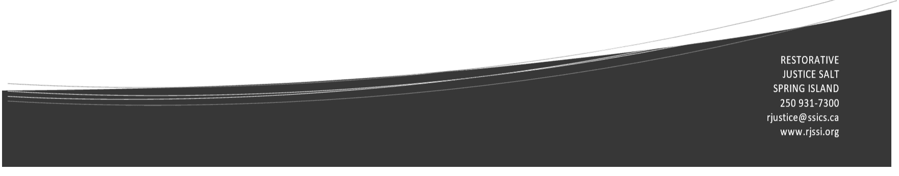 **What is RESTORATIVE JUSTICE?**

Restorative Justice **(RJ**) is part of the B.C. Ministry of Public Safety & Solicitor General. It provides an alternative to the retributive court system. When crime or conflict occurs, the RJ process looks at the harm that has been done and finds ways to compensate those harmed and heal the relationship between people and with the community.

RJ emphasizes **healing**, **repairing relationships** and **repairing harm** by

* addressing the needs of the person affected by the harm
* holding the person who caused the harm accountable for their actions
* involving the community in the justice process
* providing an opportunity for everyone affected by the harm to talk about what happened, the effect it had on them and what can be done to repair the harm

RJ processes value **accountability**, **safety**, **dignity**, **belonging**, **respect and connection.**

**What happens in a RESTORATIVE JUSTICE meeting or ‘dialogue’?**

* There is careful **preparation** before a meeting so that everyone knows what to expect and to make sure that the meeting will be safe
* In the meeting the facilitators ask everyone to talk about what happened and how the offence affected them**.**
* When everyone has heard about the impact of the offence and what contributed to it, each person has an opportunity to talk about what the person who caused the harm can do to repair the harm they have caused.
* The participants develop an **agreement** for actions that the person who caused the harm must complete within the time frame agreed upon. Once the person who caused the harm completes the agreement, we notify the referring agency (e.g. RCMP) who closes the file. No criminal record will remain.

**What is RESTORATIVE JUSTICE?**

Restorative Justice **(RJ**) is part of the B.C. Ministry of Public Safety & Solicitor General. It provides an alternative to the retributive court system. When crime or conflict occurs, the RJ process looks at the harm that has been done and finds ways to compensate those harmed and heal the relationship between people and with the community.

RJ emphasizes **healing**, **repairing relationships** and **repairing harm** by

* addressing the needs of the person affected by the harm
* holding the person who caused the harm accountable for their actions
* involving the community in the justice process
* providing an opportunity for everyone affected by the harm to talk about what happened, the effect it had on them and what can be done to repair the harm

RJ processes value **accountability**, **safety**, **dignity**, **belonging**, **respect and connection.**