Talking Circles
An on-line experiential workshop

Participant’s Guide

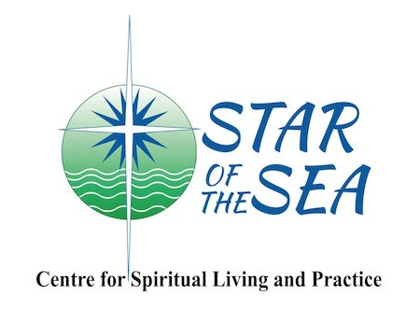

May 7th, 2020

May 7th, 2020
10:00 a.m.-12:00 p.m.

Facilitator: Laura Dafoe

laurad@saltspring.com

Circles are modeled after natural cycles within the universe. Communities have always used some form of Circles and many still use Circles within their daily lives. In our creation mythology, our stories reflect how life is set in motion by circular patterns, how the sun, moon and universe are Circles; the campfire in the snow establishes a Circle: when we drop a stone in the water, the ripples make Circles.

Just like the potlatches when we give gifts and throw away our differences and difficulties, our problems disappear like the ripples in the water. If you establish Circles it is also important to set up ceremonies that enable everyone to be comfortable and to honour the process. It may not be a Potlatch but some form of honouring the parties and their families that allow their differences to be resolved in a good way is needed.

(Mark Wedge, Carcross Tagish First Nation, Yukon, Canada)

Talking Circles

The foundation of the Circle’s structure is made up of two components: first, values that nurture good relationships and, second, key teachings common among indigenous communities. Together, relationship-supportive values and ancient teachings create a strong base for developing the practice of respectful communication. The values and teachings create a container that can hold anger, frustration, joy, celebration, pain, truth, conflict, diverse worldviews, intense feelings and silence.

By creating a safe space, participants feel comfortable speaking their truth to one another on an equal basis. From this place a deeper understanding of themselves and others is nurtured.

Seven Core Assumptions Underlying the Circle Process

1. The True Self in everyone is good, wise and powerful.
2. The world is profoundly interconnected.
3. All human beings have a deep desire to be in a good relationship.
4. All humans have gifts. Everyone is needed for what they bring.
5. Everything we need to make positive change is already here.
6. Human beings are holistic. Our minds, bodies, emotions and spirits are equally important.
7. We need practices to build habits of living from the core self.

Circle Applications

- developing emotional awareness and literacy
- increasing support and accountability in families
- building relationships in a family or other group
- connecting with others who have a shared task or interest
- exploring healthy relationships
- family decision-making and problem solving
- teaching, learning, healing
- processing difficult experiences
- working through disagreements or conflicts

“Your presence is the greatest gift you can give to another human being.”
Marshall Rosenberg

Essential Elements of the Circle

- Seating of all participants in a circle (preferably without any tables)
- Opening Ceremony
- Centerpiece
- Discussing values and guidelines
- Talking piece
- Guiding questions
- Closing Ceremony

Ceremonies

- Ceremonies are more meaningful when developed by the people involved
- Ceremonies help invite the spiritual into the Circle
- Ceremonies draw strength from tradition, culture and relationships

Circle Keepers

Circle Keepers are not traditional leaders, they are in fact the servants of the group and respond to the needs and direction that the group is taking.

Circle Keepers generally perform the following tasks:
- Plan the location, time and logistics of the meeting
- Provide access to information
- Plan an appropriate ceremony
- Arrange for a meaningful talking piece
- Arrange for participant to be welcomed
- Ask the question that will start each round
- Summarize what the participants have been saying
- Maintain focus
- Step back and allow the Circle to care for itself
- Encourage others to take responsibility for the Circle
- Nudge the process into the next stage
- Ensure that all interests are represented and balanced
- Call breaks
- Participate in the Circle
- Model the principles of a Talking Circle
- Begin well and end well

Circle Guidelines

- Every Circle process must be led by a set of guidelines.
- Guidelines are not rules, but rather mutually agreed-upon standards that help to keep the group working toward the same vision.

Guidelines essential for all Talking Circles

- Respect the talking piece
- Speak from the heart
- Speak with respect
- Listen with respect
- Remain in the Circle
- Honour Confidentiality

Group Agreement Suggestions

- Share only your personal experience and learning without reference to the stories of others.
- If you are sharing your circle experience with others, please leave out names and details that might identify other people.
- What is said in the circle, stays in the circle.
- Keep body language respectful.

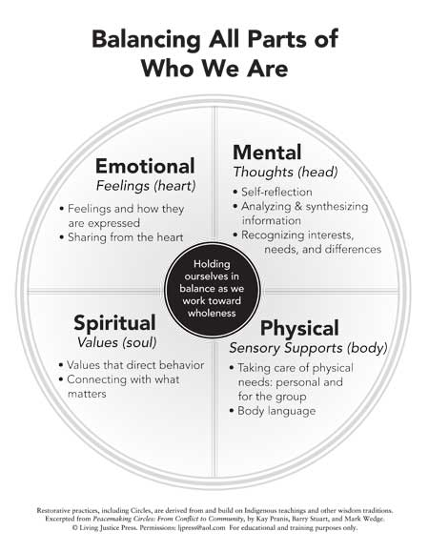
.

The Talking Piece

Choosing a Talking Piece

What each group uses as a talking piece depends on the customs within the community or what a keeper believes will best serve the Circle.

The importance of a talking piece warrants taking time to carefully choose an appropriate talking piece; one that helps create a spiritual connection to the Circle. A talking piece can be the primary symbol representing the values of the Circle — respect, honesty, trust, inclusivity, sharing, love, and forgiveness. A talking piece with this symbolic significance reminds speakers of these values when holding it.

The reasons for having chosen a talking piece should be shared at the opening of the Circle so that its significance can be understood and shared.

Any object, if it symbolizes for a group the importance of speaking from the heart, speaking openly, honestly and of listening openly and respectfully, will be appropriate.
The more meaning an object has to the group, the more effective it will be in reminding people of underlying Circle values and guidelines.

Basic Guidelines for the Talking Piece

- The talking piece moves always in the same direction around the Circle, usually clockwise, in the same way the earth moves around the sun
- One speaks only when holding the talking piece, except with the permission of the keeper
- The talking piece imposes no obligation to speak. It can be passed without speaking, or held to bring the Circle into a moment of shared silence.
- Once the talking piece moves around the Circle and comes back to the keeper, the keeper may:
~summarize what has been shared in the Circle
~raise questions before passing the talking piece around again
~hold it and open the Circle for anyone to speak
~hold it and call upon specific participants to clarify or respond to
particular issues
~place it in the center for anyone to pick up and use to speak
~pass it to someone else to start another round of the Circle

The Center Piece
Typically, there is a cloth or mat as the base. The centerpiece creates a focal point that brings everyone together and supports speaking from the heart and listening from the heart. The centerpiece should reinforce the values that undergird the process. A candle is often used to represent the ancient tradition of gathering around the fire.

The Circle Outline

Welcome
Opening
Explain the centerpiece
Explain the talking piece
State the purpose
Introduction/check-in round
Agree on Values/Guidelines
Story-telling round
Explore the topic of the Circle using guiding questions
Check-out round
Thanks
Closing

Questions for the Circle Keepers

Here are some examples of the kinds of questions you can offer to help start each new round in your Circle:

“How are you feeling about …… ?

“What are you needing at this time?”

“Can we imagine some new ways to deal with these challenges?”

“How do you see the situation that brought us here today”?

“Let’s brainstorm possible solutions to this problem”

“What are you willing to do to help resolve this conflict?”

“How is this discussion making you feel right now?”

“What has surprised you about today”?

Quotes and Poems Suggestions
for opening and closing ceremonies

Mother Teresa's Anyway Poem
People are often unreasonable, illogical and self centered;
Forgive them anyway.
If you are kind, people may accuse you of selfish, ulterior motives;
Be kind anyway.
If you are successful, you will win some false friends and some true enemies;
Succeed anyway.
If you are honest and frank, people may cheat you;
Be honest and frank anyway.
What you spend years building, someone could destroy overnight;
Build anyway.
If you find serenity and happiness, they may be jealous;
Be happy anyway.
The good you do today, people will often forget tomorrow;
Do good anyway.
Give the world the best you have, and it may never be enough;
Give the world the best you've got anyway.
You see, in the final analysis, it is between you and your God;
It was never between you and them anyway.

You can search throughout the entire universe for someone who is more deserving of your love and affection than you are yourself, and that person is not to be found anywhere. You yourself, as much as anybody in the entire universe deserve your love and affection.
Buddha

Slow me down
Ease the pounding of my heart
By the quieting of my mind
Steady my hurried pace
With a vision of the eternal reach of time.
Give me amidst the confusion of my day
The calmness of the everlasting hills
Break the tensions of my nerves and muscles
With the soothing music of the singing streams
That live in my memory.
Help me to know
The magical restoring power of sleep
Teach me the art
Of taking minute vacations
Of slowing down to look at a flower
To chat with a friend
To pat a dog
To read a few lines from a good book.
Remind me each day of the fable
Of the hare and the tortoise
That I may know that the race
Is not always to be swift
That there is more to life
Than measuring speed.
Let me look upward
Into the branches of the towering oak
And know that it grew great and strong
Because it grew slowly and well.
Slow me down
And inspire me to send my roots
Deep into the soil
Of life's enduring values
That I may grow towards the stars
Of my enduring destiny.

Unknown

“Teach your children what we have taught our children, that the earth is our mother. Whatever befalls the earth befalls the sons of the earth. If men spit upon the ground, they spit upon themselves.
This we know: the earth does not belong to man - man belongs to the earth. This we know. All things are connected like the blood that unites one's family. All things are connected.”
― Chief Seattle (Sealth), Suquamish Chie

“We all take different paths in life,
But no matter where we go,
We take a little of each other everywhere.”
Tim McGraw

The intuitive mind is a sacred gift and the rational mind is a faithful servant. We have created a society that honors the servant and has forgotten the gift.
Albert Einstein

Connections, by Marge Piercy
Connections are made slowly, sometimes they grow underground.
You cannot always tell by looking at what is happening
More than half a tree is spread out in the soil under your feet.
Penetrate quietly as the earthworm that blows no trumpet.
Fight persistently as the creeper that brings down the tree.
Spread like the squash plant that overruns the garden
Gnaw in the dark, and use the sun to make sugar.
Weave real connections, create real nodes, build real houses.
Live a life you can endure: make life that is loving.
Keep tangling and interweaving and taking more in, a thicket and bramble
wilderness to the outside but to us it is interconnected with rabbit runs and burrows and lairs.
This is how we are going to live for a long time: not always.
For every gardener knows that after the digging, after the planting, after the long season of tending and growth, the harvest comes.

Circle Haikus By Christine Park

The circle helps us
In our collective journey
To learn what we know

Coming together
We explore the power of
Endless beginnings

The path is made clear
Are we brave enough to try?
With faith we dive in
One initiates
But everyone is equal
In this sacred shape

Layer by layer
Our facades begin to fall
What will be exposed?

Sorrow, pain and joy
Questions, fears, hopes, desires
There is space for all

In every circle
Is an endless supply of
Possibilities
When there is conflict
(for it most surely will come)
Trust in the process

Be patient and watch
Transformation transpire—
Change, is, possible.

We listen and share
As the talking piece is passed
Understanding grows

Our stories reveal
The deep connections we share—
Healing. Can. Happen.

In this mystery
We are bound to discover
The secret of life:

There is a wisdom
To be found in each of us—
Our truth rests within

“We approach our lives on different trajectories, each of us spinning in our own separate, shining orbit. What gives this life its resonance is when those trajectories cross and we become engaged with each other, for as long or as fleeting as we do. There’s a shared energy then, and it can feel as though the whole universe is in the process of coming together. Every encounter has within it the power of enchantment, if we’re willing to look for it.”
Richard Wagamese

Circles transform conflicts into opportunities by applying ancient wisdom about human relationships. This wisdom begins with appreciating the role that values have in human conduct. Values are our compass in life. The values we bring to a situation determine how we respond. Before dealing with any conflict, therefore, we need to clarify our values. What values can help us work through our differences in the best way possible?
Kay Pranis, Barry Stuart, Mark Wedge

“The quieter you become, the more you can hear.” Ram Dass

With gratitude for the following resources:
Boyes-Watson, Carolyn & Pranis, K, Heart of Hope A Guide for Using Peacemaking Circles to Develop Emotional Literacy, Promote Healing & Build Healthy Relationships, Living Justice Press, 2010
Pranis, K. (2005). The Little Book of Circle Process. Good Books. 2005
Pranis, K., Stuart, B., & Wedge, M. (2003). Peacemaking Circles: From Crime to Community. St. Paul, MN: Living Justice Press
White, Gordon, Peace Making Circles Guide

